Most Popular Language in World-X
John Wensink
ITS410 Database Management
Colorado State University-Global Campus
Dr. Dan Morrill
December 8, 2019

Most Popular Language in World-X
This week our assignment was to list countries and their capitals where less than 30% of the population speaks English. We needed to apply our skills with querying a single database, as well as adding to those skills in order to use multiple join statements to present meaningful results (Boronczyk, 2015). The data we needed was located across multiple tables including ‘country’, ‘city’, and countrylanguage. The query can be broken up into three main parts. The first part is a simple select statement where we chose which columns would be relevant to our query. Executing the select statement by itself returns an error, as there is no city.name column in the ‘country’ table. We needed to add an inner join statement in order to use columns from the ‘city’ table based on the city.id. Meaningful results require that we reference the country.capital’s name with the city.id in order to retrieve the city’s name as opposed to its numeric city.id. This assignment necessitated another join statement, with a where clause specifying the condition that only countries where language = English and the percentage of English speakers was less than 30%. The ‘and’ modifier was used for this task, indicating there were two criteria that needed to be met, country.langage = ‘English’ and countrylanguage.percentage was less than thirty (W3resource, 2019). For easy readability, the result columns were renamed ‘Country’ and ‘Capital.’ The syntax for this query was a process of trial and error. There were many unsuccessful attempts at displaying the data in a useful way. One of the most difficult parts was getting the capital cities to return as city names rather than city ids. The inner join city on country.capital = city.id was where I kept getting tripped up and I must thank a guest user on (Pastebin, 2019) for showing me the correct syntax. The complete code is six lines long. Simple and eloquent:
SELECT country.name AS Country, city.name AS Capital
FROM country
INNER JOIN city on country.capital = city.id
INNER JOIN countrylanguage on country.code = countrylanguage.countrycode
WHERE countrylanguage.language = 'English'
AND countrylanguage.percentage < 30
This query produces the desired result of countries and their capitals where English is spoken by less than 30% of the population. 46 rows were returned:
Aruba Oranjestad
Anguilla The Valley
Netherlands Antilles Willemstad
American Samoa Fagatogo
Antigua and Barbuda Saint John´s
Bahrain al-Manama
Barbados Bridgetown
Brunei Bandar Seri Begawan
Cocos (Keeling) Islands West Island
Cook Islands Avarua
Christmas Island Flying Fish Cove
Cayman Islands George Town
Denmark København
Falkland Islands Stanley
Hong Kong Victoria
Iceland Reykjavík
Japan Tokyo
Saint Kitts and Nevis Basseterre
Kuwait Kuwait
Saint Lucia Castries
Lesotho Maseru
Macao Macao
Monaco Monaco-Ville
Maldives Male
Marshall Islands Dalap-Uliga-Darrit
Malta Valletta
Northern Mariana Islands Garapan
Montserrat Plymouth
Malaysia Kuala Lumpur
Norfolk Island Kingston
Niue Alofi
Norway Oslo
Nauru Yaren
Palau Koror
Saint Helena Jamestown
Seychelles Victoria
Turks and Caicos Islands Cockburn Town
Tokelau Fakaofo
Tonga Nuku´alofa
Tuvalu Funafuti
Saint Vincent and the Grenadines Kingstown
Virgin Islands, British Road Town
Vanuatu Port-Vila
Samoa Apia
South Africa Pretoria
Zimbabwe Harare
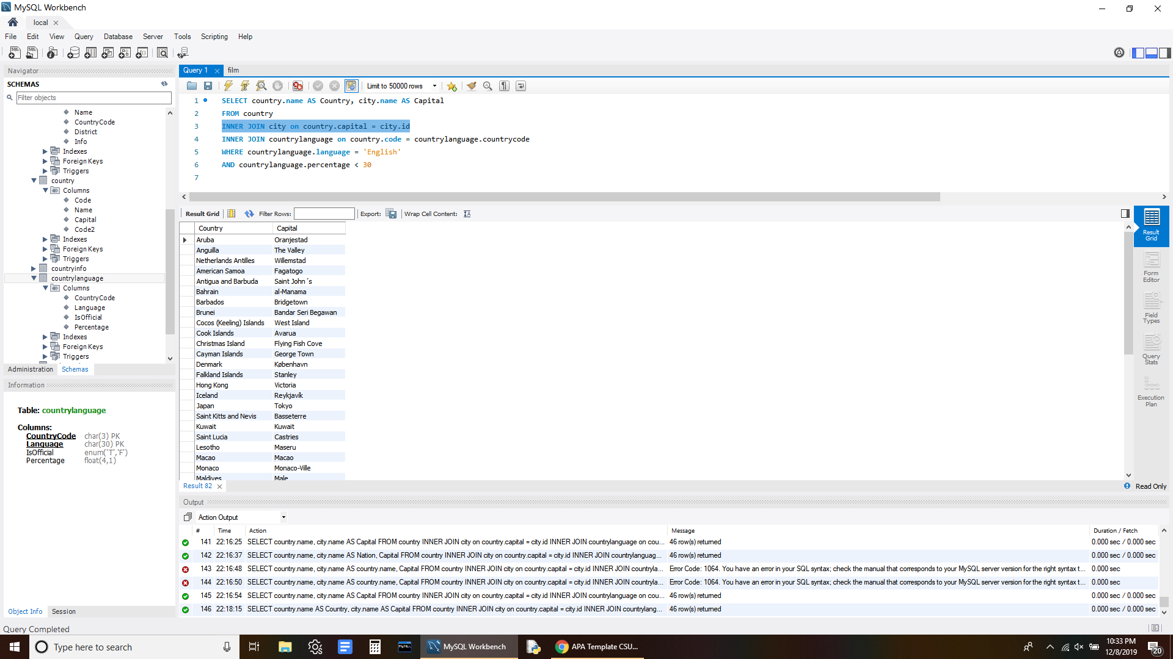

References
Boronczyk, T. (2015). Jump Start MySQL. Retrieved December 8, 2019 from https://bookshelf.vitalsource.com/#/books/9781457192838/cfi/69!/4/4@0.00:16.1
Pastebin. (2019, November 26). 1. SELECT COUNT(Name) FROM Country CROSS JOIN CountryLanguage; 2. 1. SELE. Retrieved December 8, 2019, from https://pastebin.com/aA5uGJ1e.
W3resource. (2019, November 9). SQL INNER JOIN. Retrieved December 8, 2019, from https://www.w3resource.com/sql/joins/perform-an-inner-join.php.

